Deep Learning Performance metrics on HAR with Wearable Sensor (Mobile) on Custom dataset
 | LSTM | BiLSTM | GRS-BiLSTM | MS-GRS-BiLSTM
Precision | 0.826493 | 0.879853 | 0.929214 | 0.967921
Recall | 0.807268 | 0.862020 | 0.927349 | 0.968486
F1-score | 0.806628 | 0.860110 | 0.927426 | 0.968763
Test Accuracy | 0.806886 | 0.862275 | 0.927395 | 0.968937
Test Loss | 0.3746 | 0.2357 | 0.106525 | 0.077365
Model Parameters | 32,775 | 84,040 | 556,104 | 559,176
Model Size | 0.1250 MB | 0.3206 MB | 2.1214 MB | 2.1373 MB
Avg Batch Inference Time | 0.008822 sec | 0.014246 sec | 0.017332 sec | 0.017672 sec
Single Sample Inference Time | 0.004555 sec | 0.002505 sec | 0.008718 sec | 0.009988 sec

Confusion Matrix
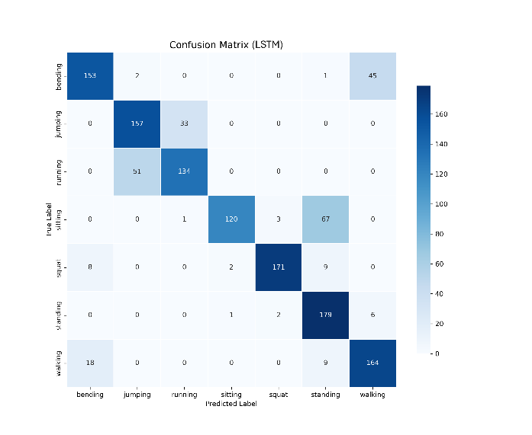 | 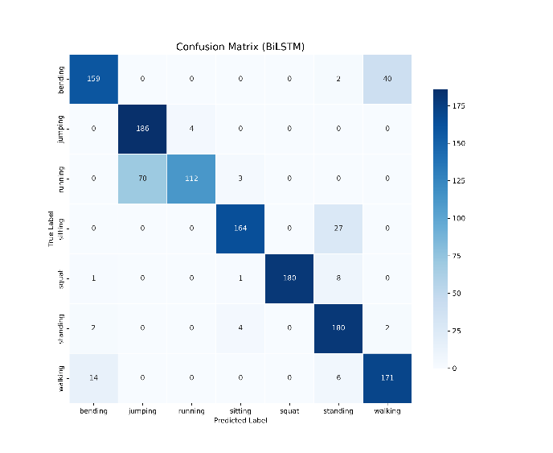
LSTM | BiLSTM
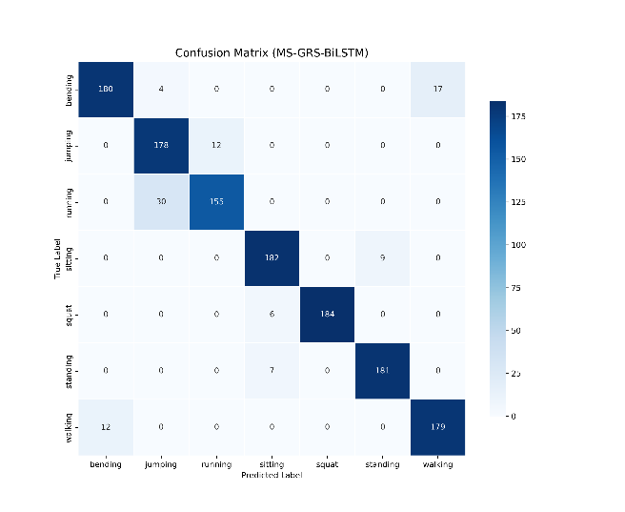 | 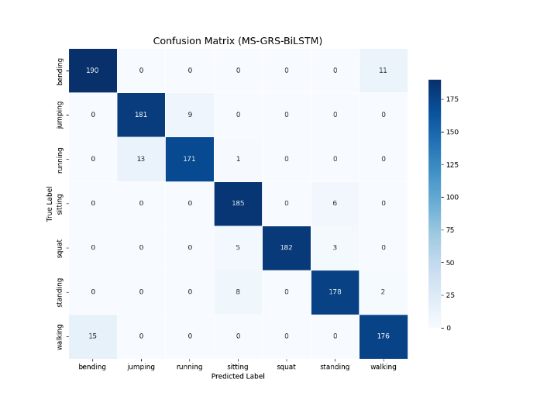
GRS-BiLSTM | MS-GRS-BiLSTM

Accuracy and Loss Curve
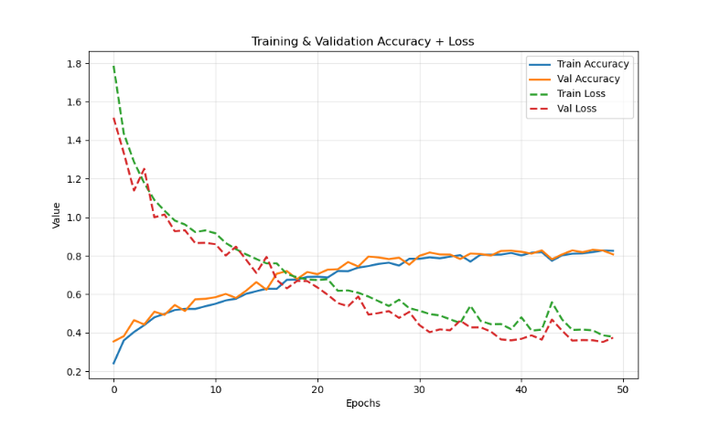 | 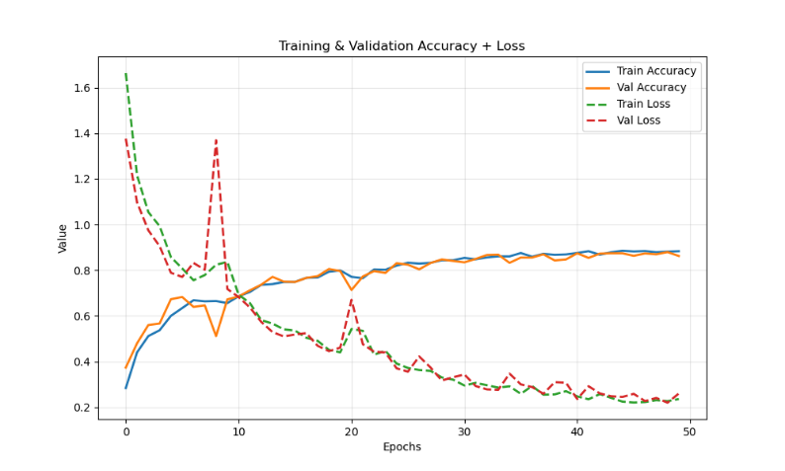
LSTM | BiLSTM
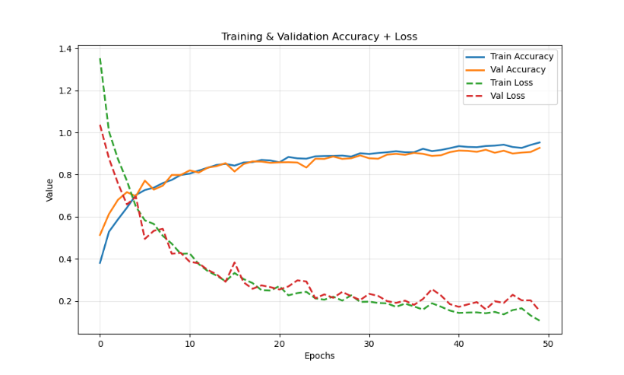 | 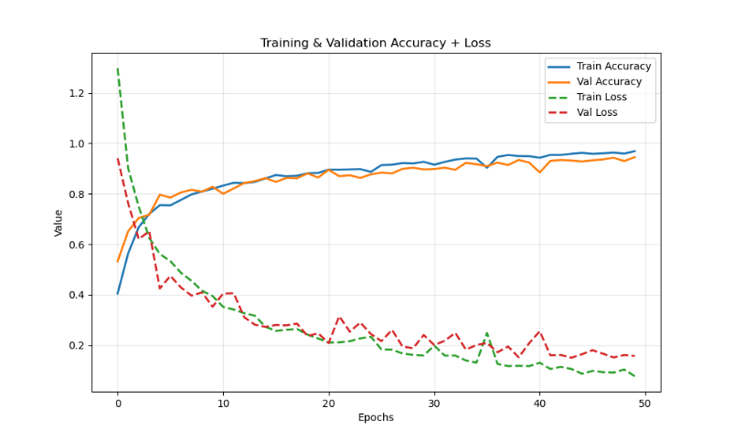
GRS-BiLSTM | MS-GRS-BiLSTM

